Report about best devices in PC, best operating system and suitable programming languages.
System Name:
- Best Devices
Any PC or laptop with CPU core I 3 or more and 8G ram to open the wpf and database smoothly and fast

- Best Operating System
it needs a device with windows 10 or windows 11 Operating System because it support the c# .net and SQL database and XAML .

- Suitable Programming Languages
SQL : for database and store the Receptionist and Doctor data
C# : for the logice of the app
Xaml : for the UI of the app

- Suitable Applications

Design of an integrated system (Class diagram)

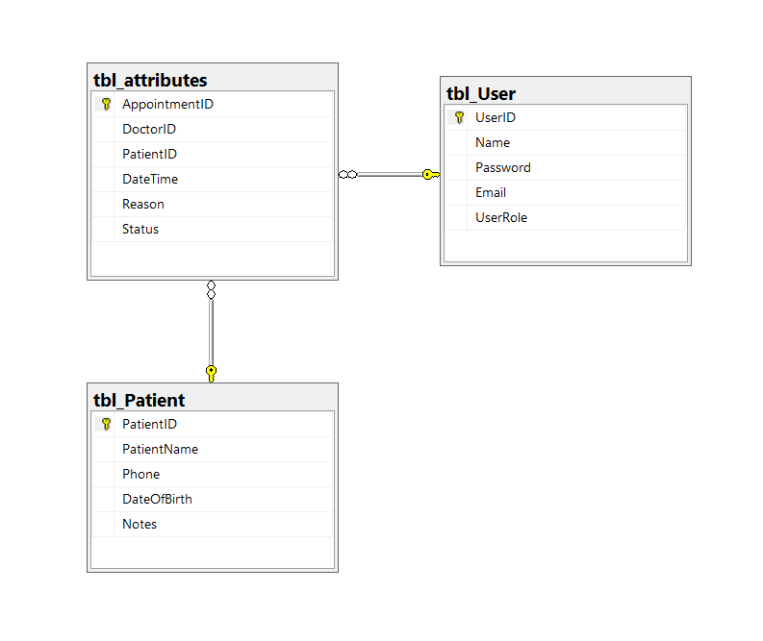

Testing
Test case ID | Test case description | Test Steps | Test Data | Expected Result | Actual Result | Pass/Fail
1 | Log in with empty data | Enter empty username and password | Username :  Null  password :  null | Show Error massege | Show Error massege | pass
2 | Log in with wrong data | Enter wrong username and password | Username :  hi  password :  hi | Show Error massege | Show Error massege | Pass
3 | Log in with right data | Enter right username and password | Username :  shin  password :  pass | Enter page | Show Error massege | fail
4 | Log in with right data | Enter right username and password | Username :  shin@  password :  pass | Enter page | Enter page | pass

